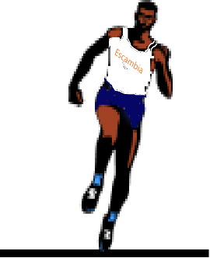
2024
EHS
TRaCK & FieLD SCHeDuLe

Date | Opponents | Place | Time
2/17(Sat) | Viking Classic | Ft. Walton | TBA
2/22(Thurs) | Pace, Milton | Pace | 4:00pm
2/23(Fri) | Andrews Inv. | Gulf Breeze | TBA
2/29(Thurs) | Pace, Milton | Milton | 4:00pm
3/2(Sat) | Aggie Inv. | Washington | TBA
3/15-16(Fri-Sat) | Bob Hayes Inv. | Jacksonville | TBA
3/16(Sat) | Wildcat Inv. | Washington | TBA
3/19(Tues) | West Fla | West Fla Tech | 3:30pm
3/22(Fri) | FSU Relays | Tallahassee | TBA
3/23(Sat) | Golden Elite Freshman/Sophomore | Washington | TBA
3/30(Sat) | Viking Relays | Ft. Walton | TBA
4/2(Tues) | West Fla | West Fla Tech | 3:30pm
4/5(Fri) | Mobile Challenge of Champions | UMS-Wright  Mobile, Al. | TBA
4/5(Fri) | Patriot Inv. | Pace | TBA
4/6(Sat) | Meet of Champions | St. Paul's Episcopal  Mobile, Al. | TBA
4/13(Sat) | Esc. Co. Championship | Washington | TBA
4/24-5/3 | District Meet | TBA | TBA
5/8(Wed) | Regional Meet | UNF, Jacksonville | TBA
5/17(Fri) | State Meet | UNF, Jacksonville | TBA

